DocuSign Part 11 Policy and Procedures

Purpose:

To establish standard processes and procedures for using the part 11 compliant version of DocuSign to assist in conducting FDA-regulated research at Virginia Commonwealth University.

Scope:

This procedure applies to activities requiring the utilization of electronic signatures for the conduct of FDA-regulated research at VCU.

Users of this system will be the investigator and the investigator delegates, including administrative and operations personnel.

This procedure does not apply to federal or state regulatory activities captured in another system, such as Veeva SiteVault.

Responsibility:

VCU personnel will be responsible for performing and complying with this procedure and ensuring that the appropriate personnel are trained.

It is VCU personnel’s responsibility to ensure that they are in the correct DocuSign account (regular university DocuSign vs. part 11 DocuSign) before sending documents for review/signature. A document sent via the university DocuSign that is intended to be sent via part 11 DocuSign is not part 11 compliant.

Definitions:
- DocuSign Part 11 Account Administrator: Is the person designated to be the Senders’ points of contact and who is responsible for configuring and managing their user accounts in the Part 11 System. In particular, Administrators set up policies (e.g., password, document retention, etc.) and manage the DocuSign user memberships on their accounts. At VCU, they are also responsible for verifying senders' Part 11 training.
- Sender: A person within VCU who uses DocuSign Part 11 to send FDA forms or consent documents to others for signing. Senders are users with account memberships responsible for creating, sending, and managing envelopes, which are logical containers for all data in the System. In addition, Senders perform many actions to envelopes, such as uploading documents, adding Recipients, defining routing orders, and placing fields on documents for Recipients.
- Signer: A person either within or outside of VCU who uses DocuSign Part 11 to sign an FDA form or consent document. Someone who receives an envelope and, depending on the settings, can sign the documents or add information where indicated by tabs/fields.
- Document: A digital file that contains content to be reviewed and/or signed/initialed by one or more recipients. Documents are always encrypted while stored in the system and can be supplied through client devices, cloud storage systems, or additional document sources. DocuSign accepts almost all document types - for example, .pdf, .docx, .rtf, .txt, .png, .xls - and you can store multiple documents in a single envelope.
- Envelope: An envelope is a container or "package" used to send documents to recipients and manage transactions. Envelopes have statuses (i.e., sent, delivered, completed, voided) and typically contain documents, recipients, and tabs/fields. They also include information about the sender, document-related metadata, and timestamps that indicate the progress of the delivery procedure. When an envelope is completed, the DocuSign platform automatically generates a Certificate of Completion, which details the entire audit history of the transaction.
- Part 11 (21 CFR 11): The FDA regulations outline specific requirements for electronic records, electronic signatures, and handwritten signatures executed on electronic records to be trustworthy, reliable, and generally equivalent to paper records and handwritten signatures executed on paper.
Compliance statement:

VCU uses DocuSign part 11 as one of the available options for signing documents related to FDA-regulated studies. DocuSign Part 11 supports compliance with 21 CFR Part 11 requirements. Documentation of DocuSign’s compliance with the validation of computerized systems can be accessed at the Office of the Vice President for Research and Innovation at VCU. The system is validated for each change.

Account Provisioning Procedures:

All individuals who will be responsible for performing administrator and developer functions in the Part 11 account (e.g., managing users, user groups, settings, custody transfer, etc.) should have the appropriate education, training, or experience to operate the system.

Before using the system, all individuals who will send DocuSign Envelopes for signature should also be appropriately trained on the processes for complying with Part 11 requirements.

Individuals who solely sign documents using DocuSign Part 11 do not need special training because they are not responsible for developing, maintaining, or using the Part 11 features of DocuSign.

User Account Requestor:
- Complete system training via RedCap. All individuals who complete the training will be provisioned a sender account. Only individuals within the Office of Vice President for Research and Innovation who will ensure training is completed and then provision accounts will have admin accounts.
- You will receive an email notification from DocuSign when your account has been created; your account will be linked to the university’s single sign-on (SSO) system. You will have 30 days to activate your account before it times out.
  - You will also receive an email from erahelp@vcu.edu with a one-time access code to use to activate your account. All subsequent access to DocuSign will be linked to the university’s SSO.
- Report inaccurate or inappropriate access to erahelp@vcu.edu immediately
- Ensure passwords are not shared

Upon separation from the university, erahelp@vcu.edu should be notified to disable account access.

Procedures on how to switch to DocuSign Part 11 from the regular university DocuSign Account:

Steps to switch accounts:
- Click your initials in the top right-hand corner of your screen
- Click switch account
- Click “VCU CFR part 11” and then confirm

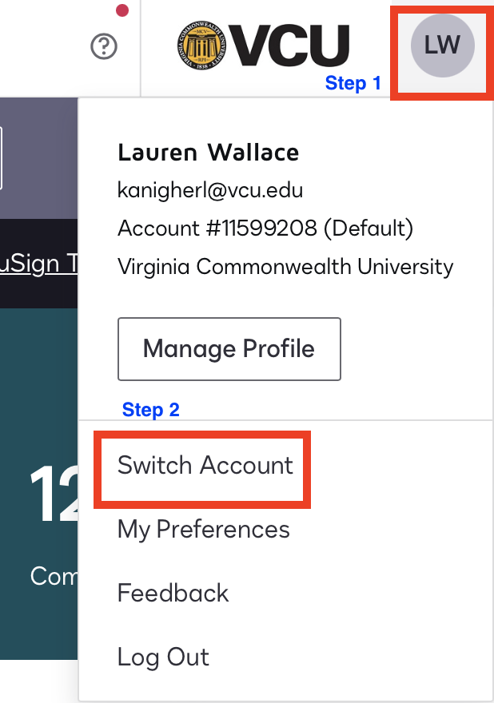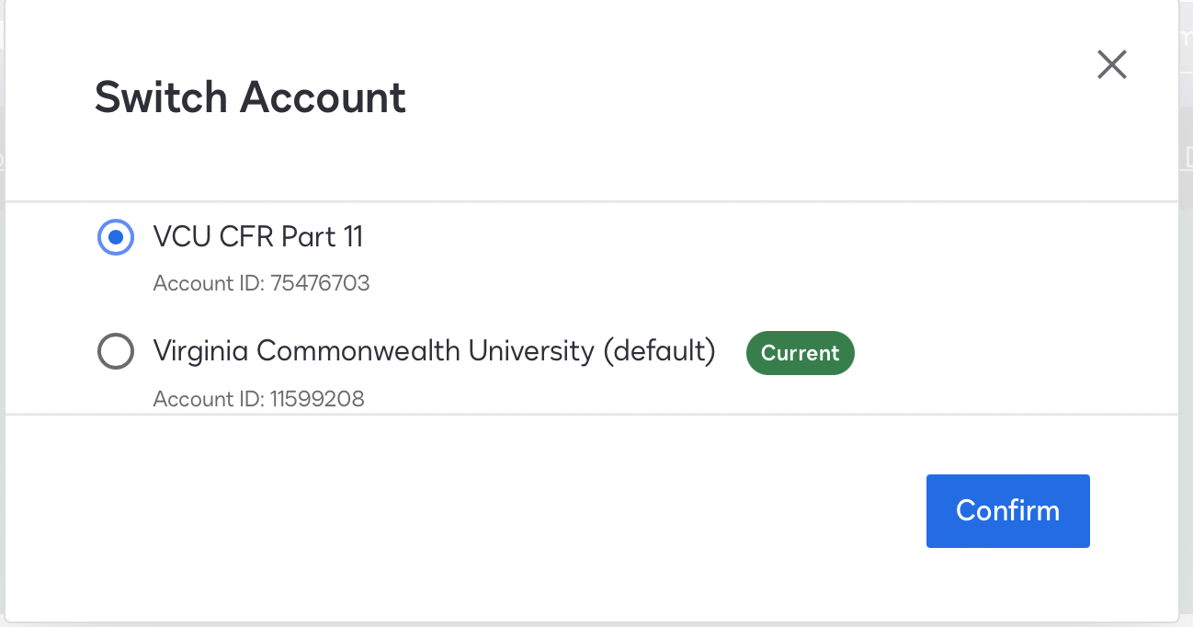

It is recommended that VCU personnel who need to send the majority of their documents to the Part 11 account change their settings so that the Part 11 account is their default account when they log into DocuSign. This will eliminate the extra steps of switching accounts every time they access the Part 11 account. The users will still have the ability to switch to the non-Part 11 account as needed, following the steps above to switch accounts.

Steps to change default account to DocuSign part 11:
- While in the part 11 account, click your initials in the top right-hand corner of your screen
- Click my preferences
- In general settings, click “set as default” in the your default eSignature account section

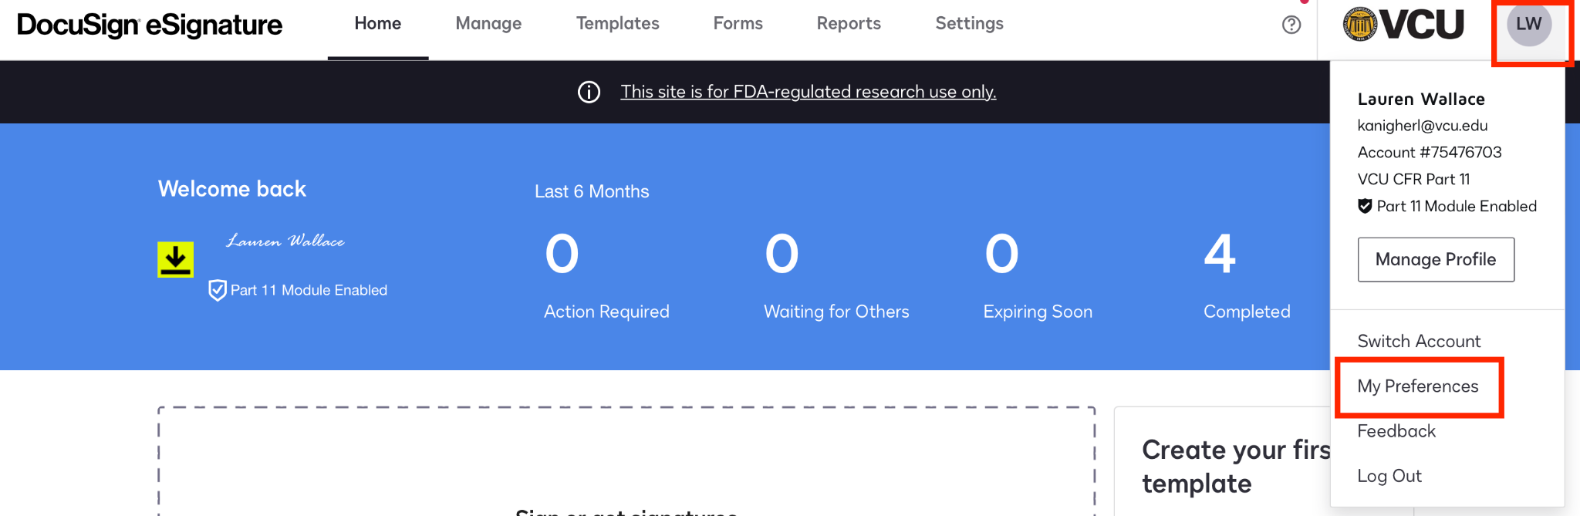
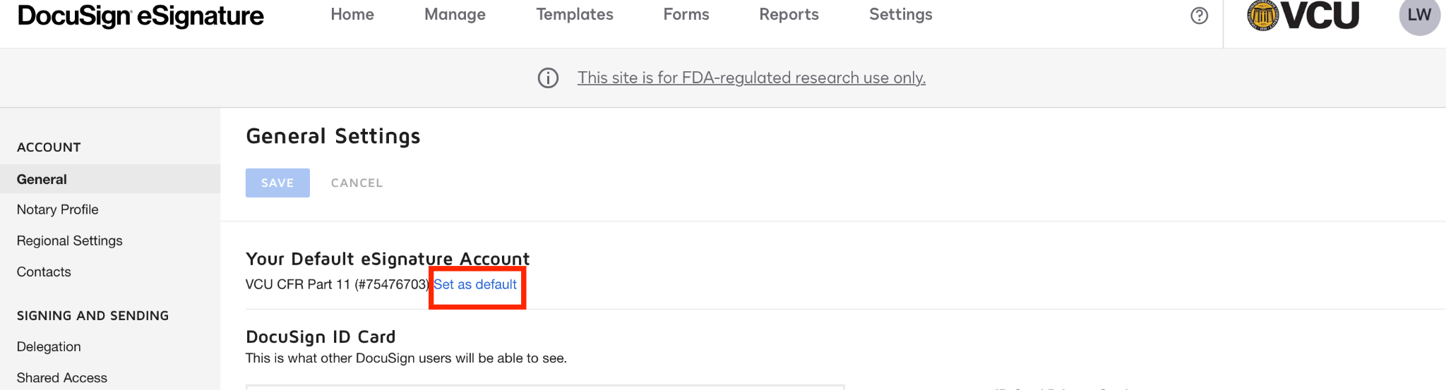

Permissible Uses of DocuSign Part 11:

DocuSign Part 11 should ONLY be used for signing documents associated with FDA-regulated studies.

This version of DocuSign may also be used for eConsent for an FDA-regulated study when the IRB of record has approved using DocuSign part 11 for eConsent. This should not be used for eConsent when the study has not been approved for remote consenting. Using DocuSign part 11 for remote consenting of participants should follow the individual’s studies IRB approval and applicable regulations.

Procedures for sending envelopes:

Senders will be able to create and send envelopes for signature(s). Signers who do not need access to send envelopes are not required to have accounts created for them prior to being sent an envelope. Internal signers to VCU will have their identity authenticated prior to opening the envelope and during the signing process through the university’s SSO. Internal signers should have envelopes sent to them using their VCU email not their VCUHS email. Signers receiving envelopes to their VCUHS emails may experience difficulties logging into DocuSign and signing envelopes due to differences in the VCUHS DocuSign environment. Not every VCUHS email is provisioned with a DocuSign account. External signers to VCU will have their identity authenticated before opening the envelope and during the signing process by logging into an existing DocuSign account or creating a DocuSign account.

Steps to sending an envelope:
- Create an envelope by uploading documents, the individual(s) email address(es), and a message. Verify that the correct email address(es) have been entered. Select “Account login for access & signatures” for CFR part 11 envelope access and signature authentication.
- Add signature fields as needed.
- Send envelope

After completing the envelope, the documents should be downloaded with their associated audit trail and saved with the other clinical study documents in their respective 21 CFR part 11 compliant system. Documents signed in Part 11 of DocuSign should be retained and archived per federal and state regulations and any contractual agreements.

References:
21 CFR PART 11—ELECTRONIC RECORDS; ELECTRONIC SIGNATURES
Code of Virginia Chapter 42.1. Uniform Electronic Transactions Act.
VCU’s DocuSign Demos and Trainings
DocuSign Support
DocuSign eSignature: Basic Terminology

FDA Guidance
- Use of Electronic Informed Consent in Clinical Investigations – Questions and Answers
- Part 11, Electronic Records; Electronic Signatures - Scope and Application: Guidance for Industry

Contacts:

Please contact the following for questions regarding this document:

Account provisioning and deactivation questions/requests/issues:
- OVPRI Research IT: erahelp@vcu.edu

Signer or sender-related issues:
- Central IT for DocuSign: docusign@vcu.edu

Policy/procedure questions or questions on uses of the system:
- Lauren Wallace, MS, RAC-Drugs
Director of Clinical Research Regulatory Affairs
kanigherl@vcu.edu

Revision History:

Date | Version | Change history
04/19/2024 | Initial | N/A

